NAME : FIKRI ANGGRA BERLIAN

NIM : L200174090

CLASS : X

**MODUL 6**

1. **BlackBox (game)**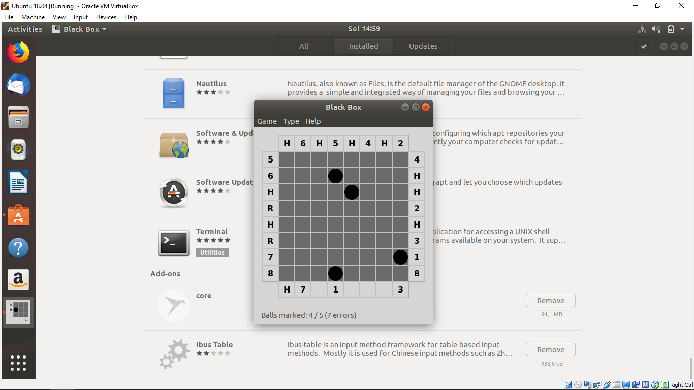
2. **Bridges(games)**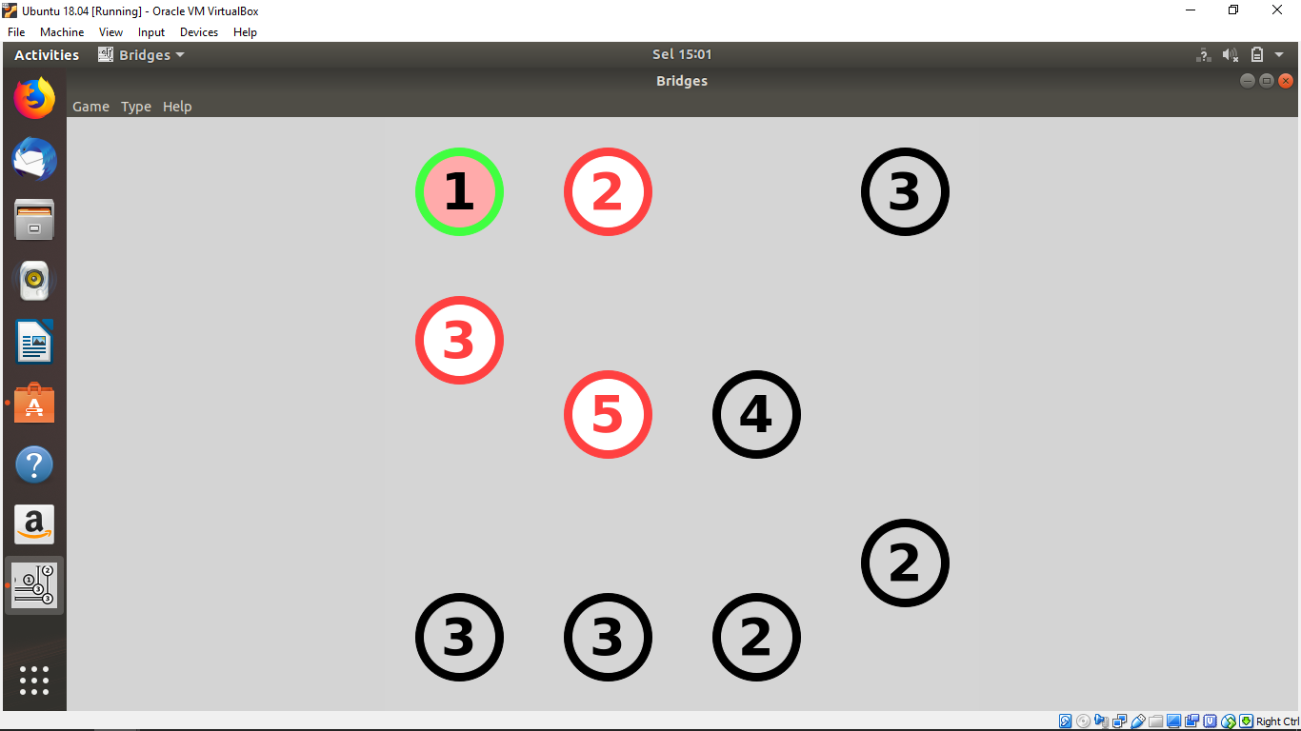
3. **Cube(games)**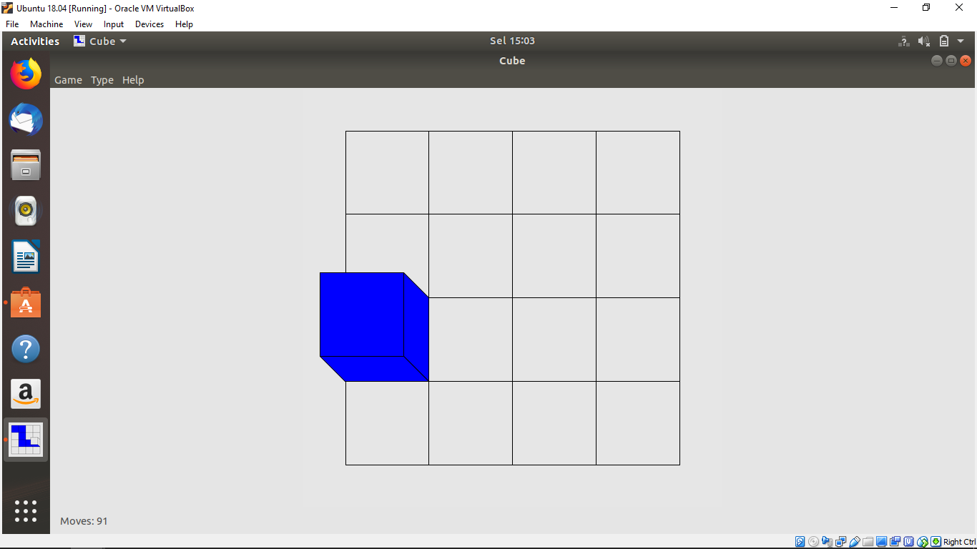
4. **Dominosa(games)**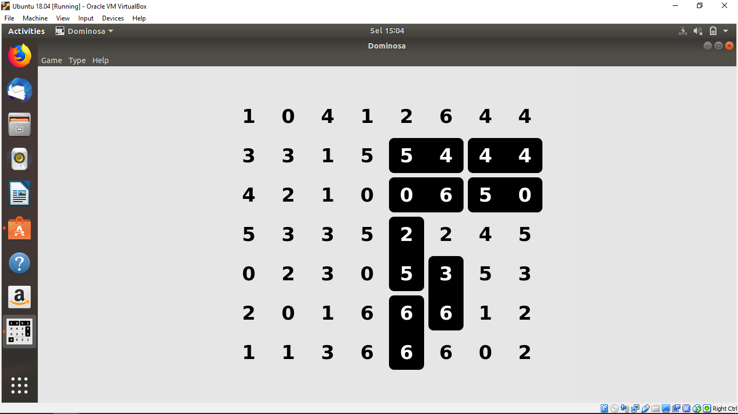
5. **DOSbox(DOS)**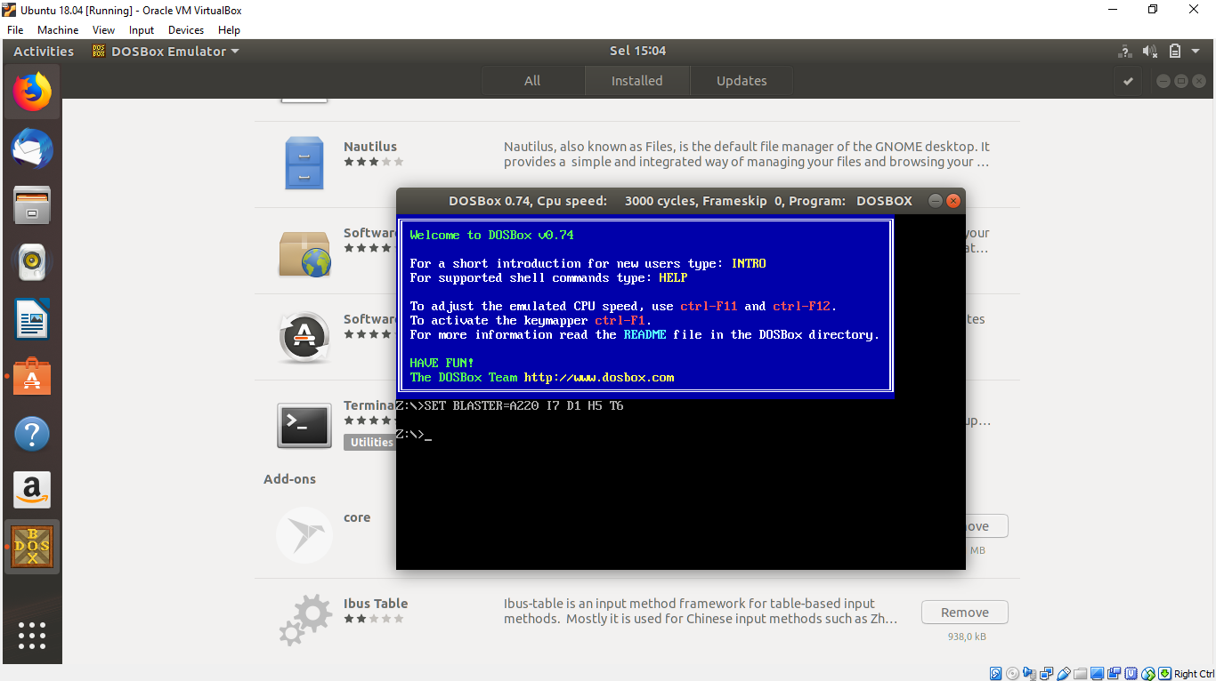
6. **Fifteen(games)**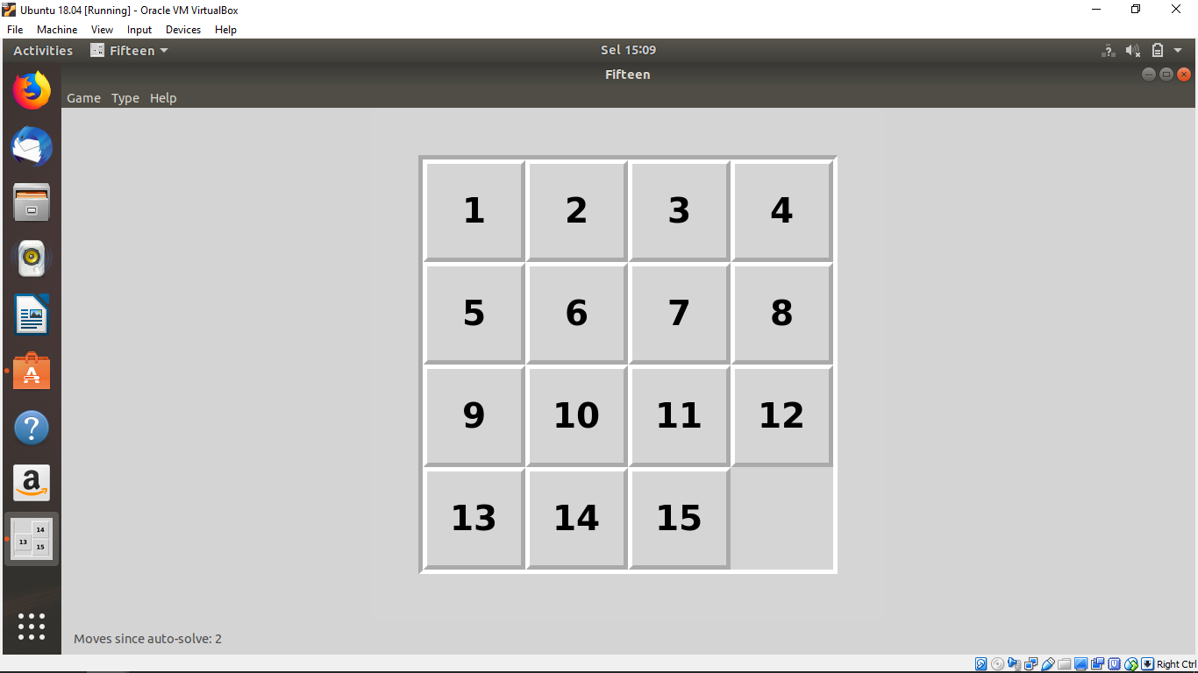
7. **Gbrainy(games)**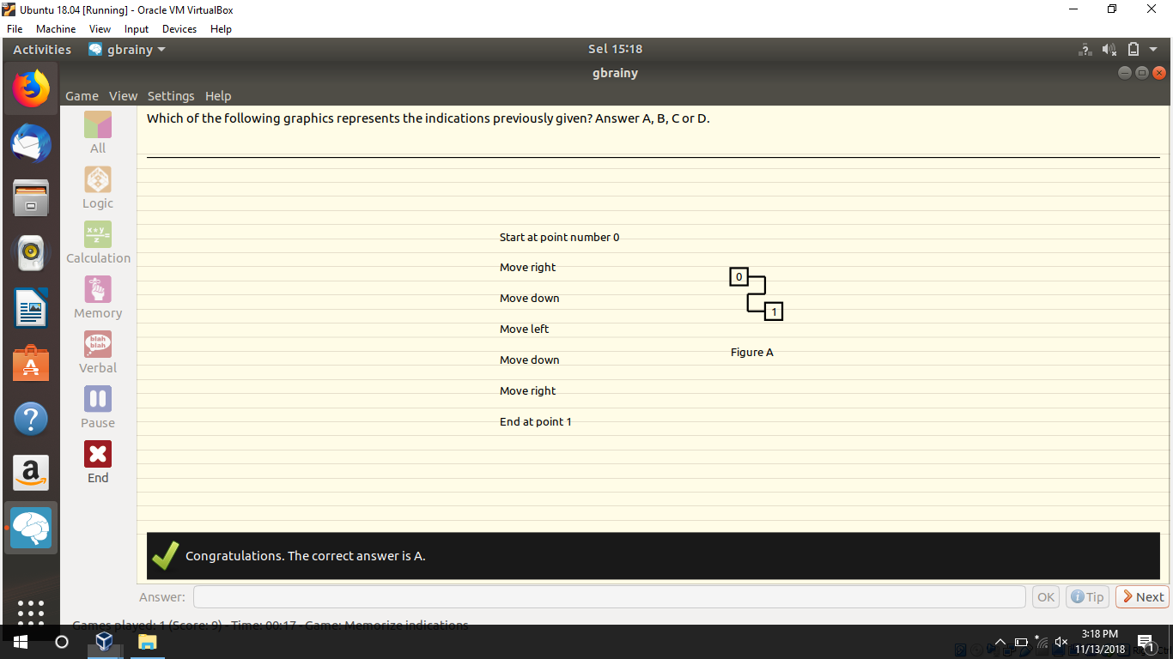
8. **Guess(games)**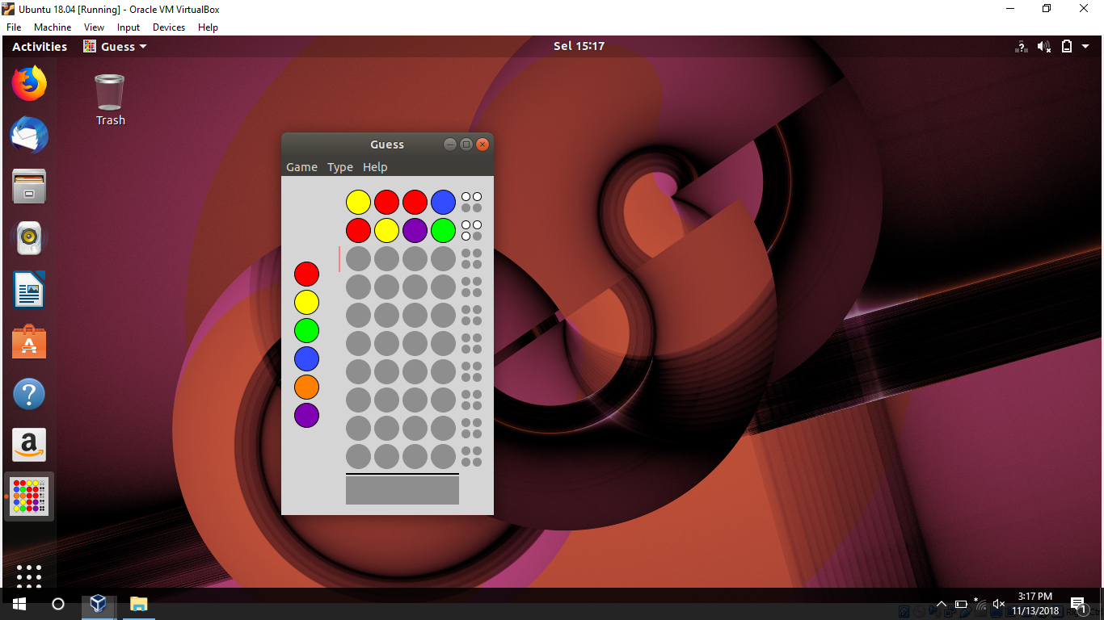
9. **Hedgewars(games)**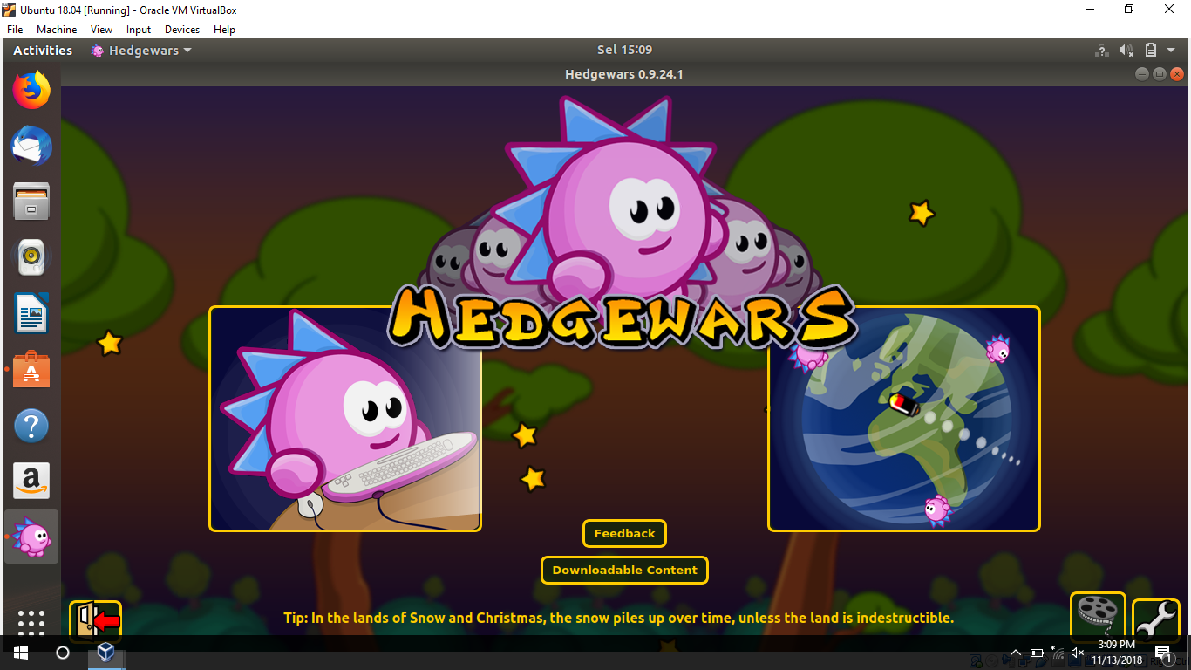
10. **Tee(multiplayer games)**